**Name:** Swagat Panda

**ID:** 2017B5A30983P

**Lab VII**

**Study the performance of Voltage Rectifiers and Clippers using LM741**

Objectives  
To study the following rectifiers and clippers using op-amp IC LM741

1. Precision Half Wave Rectifier
2. Precision Full Wave Rectifier
3. Positive Clipper
4. Negative Clipper

and draw output waveforms in each case. Also draw the schematic for each filter.

Topology of Rectifiers and Clippers

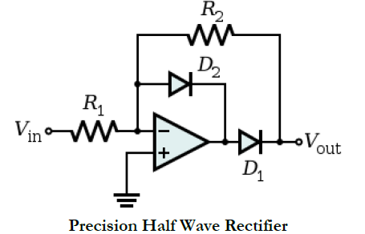 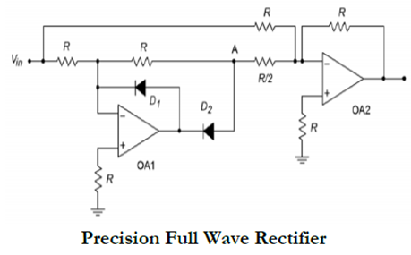

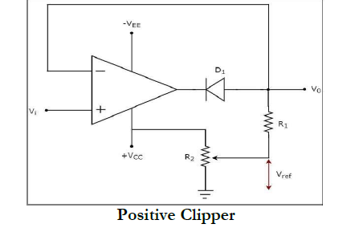 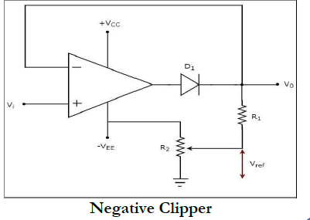

1. Precision Half Wave Rectifier

Schematic and Waveforms

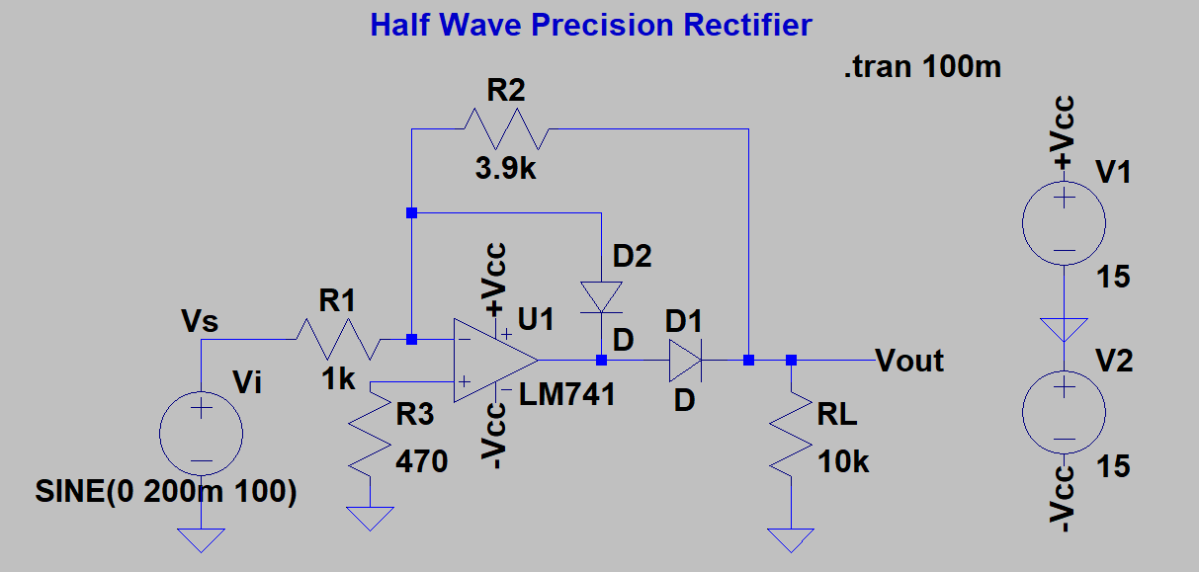

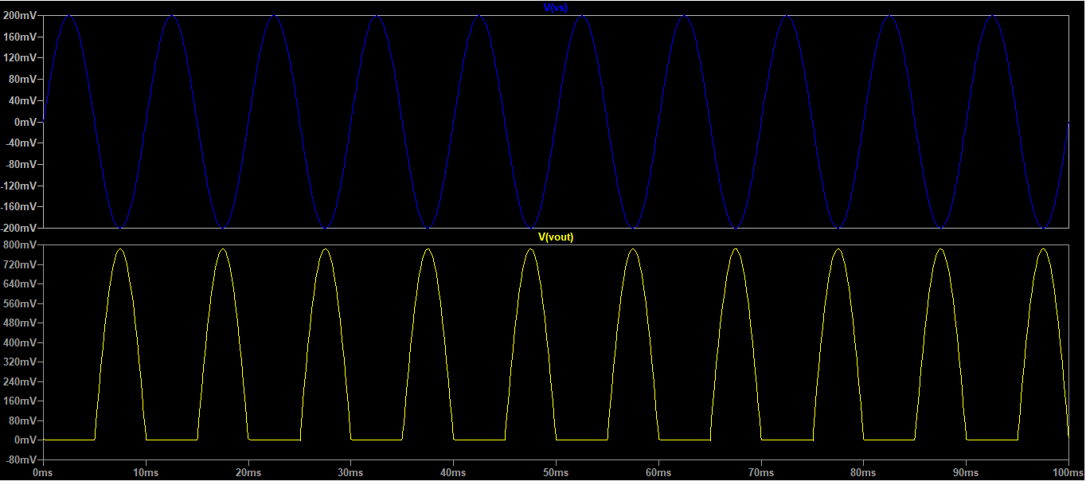

Note: All the values are from the slides of the lab session and not the board.

1. Precision Full Wave Rectifier

Schematic and Waveforms

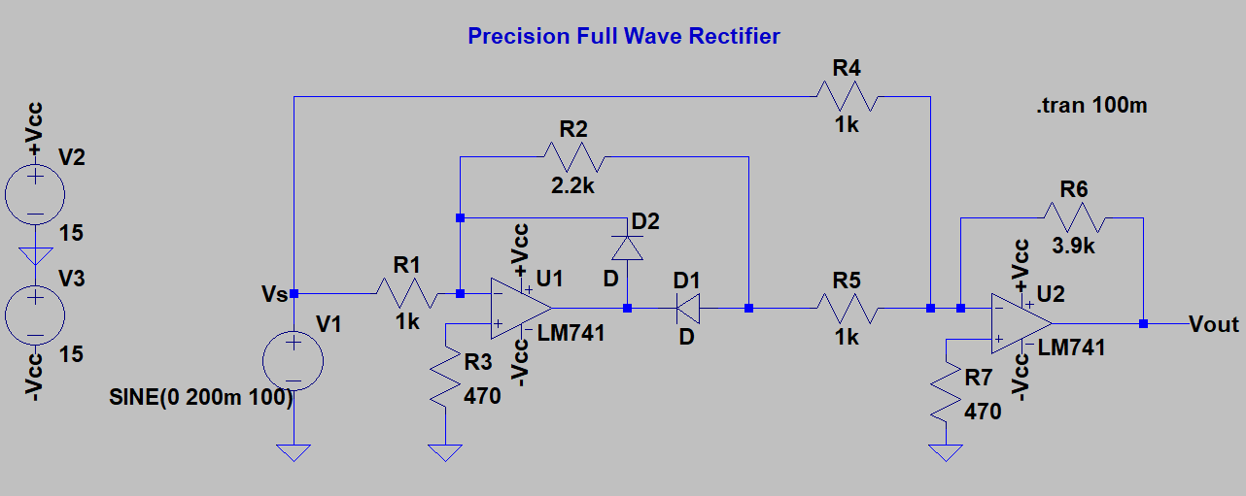

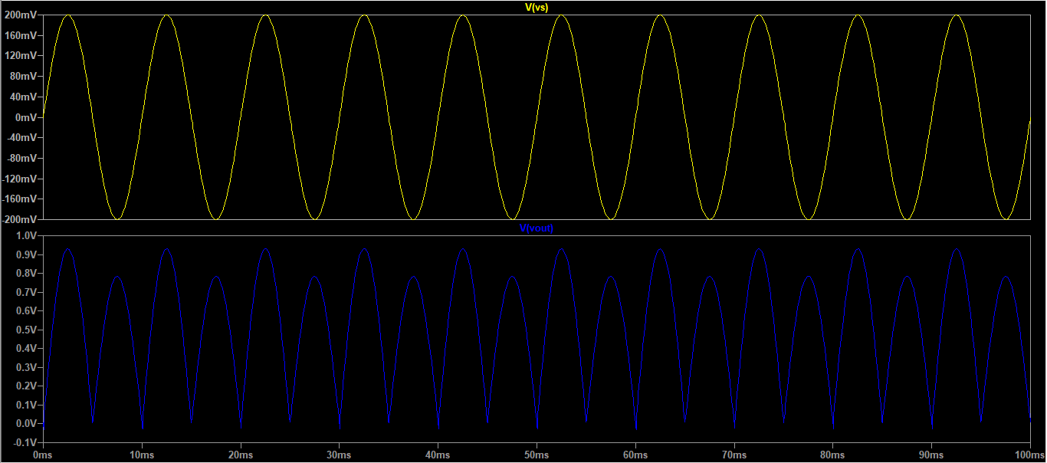

Note: All the values are from the slides of the lab session and not the board.

1. Positive Clipper

Schematic and Waveforms

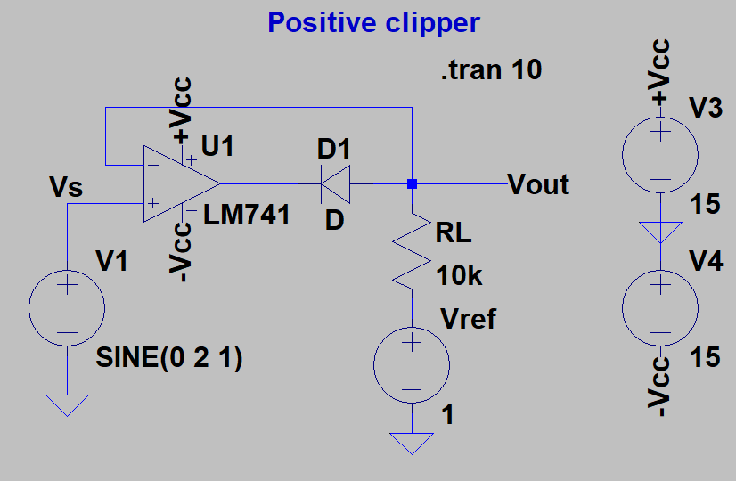

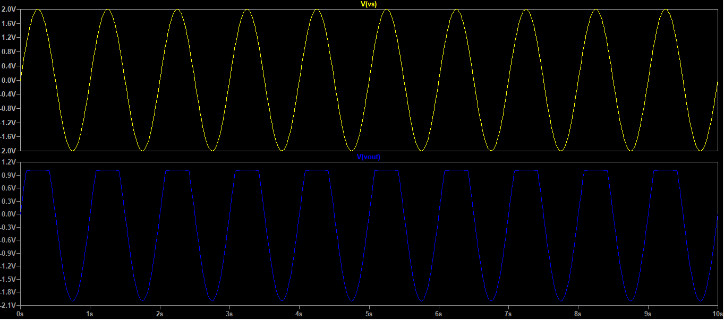

Note: All the values are from the slides of the lab session and not the board.

1. Negative Clipper

Schematic and Waveforms

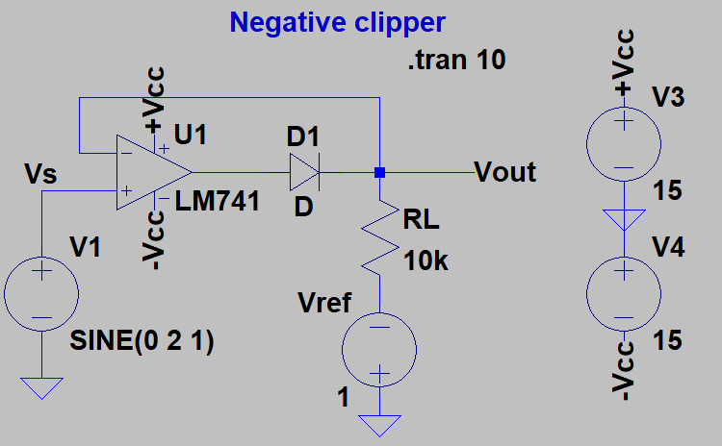

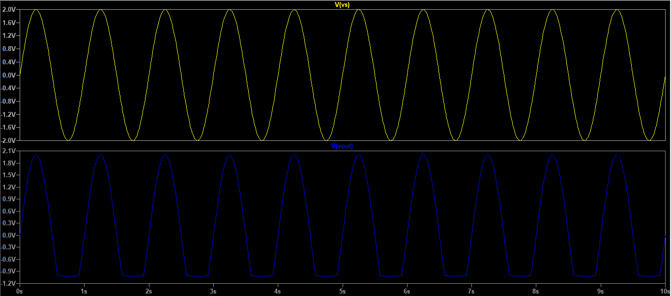

Note: All the values are from the slides of the lab session and not the board.